**📄 Microsoft Azure Database**

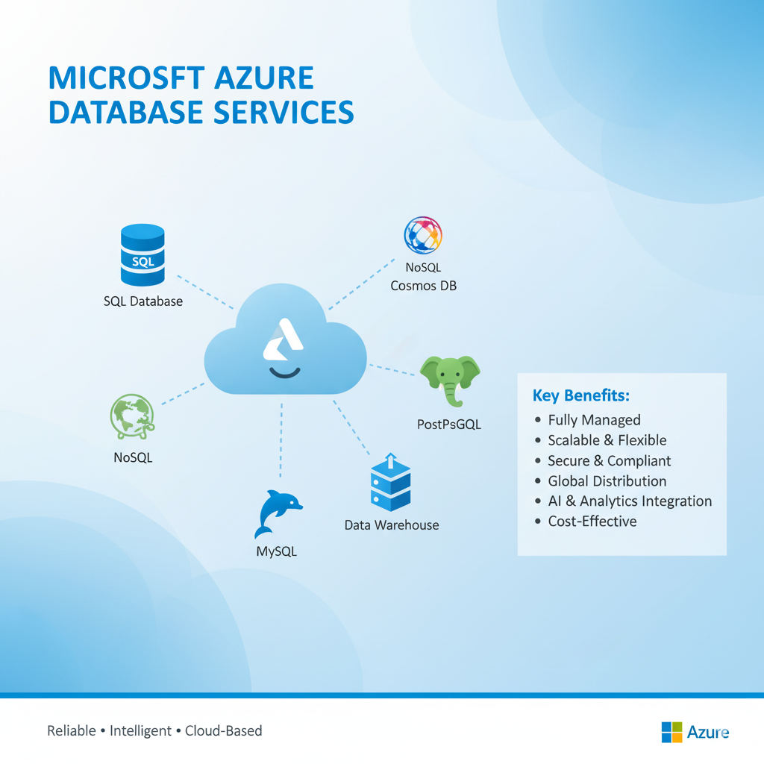

In today’s digital era, data has become the backbone of every organization. Businesses depend heavily on reliable and efficient databases to store, process, and manage critical information. Traditionally, companies hosted databases on-premises, which required expensive hardware, complex maintenance, and a team of administrators to keep them running smoothly. With the rise of cloud computing, these challenges have been addressed by offering scalable, secure, and cost-effective solutions.

Microsoft Azure, a leading cloud computing platform, provides a wide range of services to help organizations modernize their IT infrastructure. One of its most important offerings is the **Azure Database service**, which enables businesses to deploy fully managed databases on the cloud without worrying about infrastructure, security, or maintenance.

**Types of Azure Database Services**

Microsoft offers several database services under Azure:

* **Azure SQL Database**: A fully managed relational database based on Microsoft SQL Server. It is widely used for applications requiring structured data, high security, and advanced query capabilities.
* **Azure Cosmos DB**: A globally distributed, multi-model NoSQL database designed for real-time applications such as IoT, gaming, and social networks. It supports document, key-value, graph, and column-family data models.
* **Azure Database for MySQL and PostgreSQL**: Open-source relational databases that are managed and optimized on the Azure platform. They are ideal for developers building web and mobile applications.
* **Azure Database for MariaDB**: Another open-source relational database option, commonly used for enterprise and cloud-native applications.
* **Azure Synapse Analytics**: A powerful data warehousing service that allows organizations to analyze massive amounts of data and generate meaningful insights.

**Key Features and Benefits**

Microsoft Azure Database offers numerous features that make it attractive to businesses:

* **Scalability**: Databases can be scaled up or down depending on workload demand, ensuring optimal performance.
* **High Availability**: Azure provides built-in redundancy and geo-replication, which ensures that databases remain available even during outages.
* **Security**: Features like encryption, role-based access control, and advanced threat protection safeguard sensitive data.
* **Cost Efficiency**: With a pay-as-you-go pricing model, organizations only pay for the resources they use. Reserved capacity options further reduce costs for long-term workloads.
* **Integration**: Azure databases integrate seamlessly with other Azure services like AI, Machine Learning, DevOps, and Analytics.
* **Backup & Recovery**: Automated backups and point-in-time recovery ensure data safety and business continuity.

**Use Cases of Azure Database**

Azure Database can be applied in multiple industries and scenarios:

* **E-commerce platforms**: To manage large volumes of product and customer data while supporting millions of transactions daily.
* **Banking and Finance**: For secure and real-time processing of financial transactions.
* **Healthcare**: To store and analyze sensitive patient records with compliance to global regulations.
* **IoT applications**: Using Cosmos DB to process sensor data in real-time from connected devices.
* **Data Analytics and Reporting**: Leveraging Azure Synapse for generating business intelligence insights.

**Comparison with Traditional Databases**

Compared to traditional on-premises databases, Azure Database offers several advantages. Organizations no longer need to invest in costly hardware or worry about infrastructure maintenance. The deployment process is much faster, enabling businesses to launch applications quickly. Additionally, Azure provides elastic scalability, something that is difficult to achieve with traditional systems. This flexibility, combined with enterprise-grade security and global accessibility, makes cloud-based databases the preferred choice for modern enterprises.

**Challenges and Considerations**

Although Azure Database offers many benefits, there are some considerations:

* It requires a reliable internet connection since the database is hosted in the cloud.
* Pricing may vary depending on usage patterns, which requires careful monitoring.
* Migrating legacy systems to the cloud can be complex and may require additional planning.

**Conclusion**

Microsoft Azure Database is a comprehensive, reliable, and secure cloud-based solution for managing both relational and non-relational databases. It offers businesses the flexibility to scale, the confidence of strong security, and the convenience of reduced administrative overhead. With its broad range of services, from SQL databases to Cosmos DB and Synapse Analytics, Azure is capable of meeting the needs of organizations of all sizes.